# Intro To AI: Wumpus in Prolog

## Team members :

Mohamed Amine ELOUDRHIRI ID: 102825

Youssef Gaimes ID: 76592

## Supervised by : Dr.Tajjeeddine Rachidi

## Introduction:

During this project we coded an intelligent agent to solve some of the situations of the game Wumpus World. The game consists of a hunter exploring a four-by-four layout of rooms, with the main goal being hunting down the Wumpus, and the side objective of finding the gold. During his exploration he will have to be cautious of the dangerous pits, and from becoming hunted instead of hunter, and eaten by the Wumpus.

To complete this objective, we will have to implement the game as well as all the inference rules using Prolog.

## Implementation:

To implement our knowledge base, we implemented the following predicates:

adjacent([X,Y],L) :determines if L and room [X,Y]

border([X,Y]) : determines the border of [X,Y]

makestatement([X,Y]) : takes the perception of the hunter

pit([X,Y]) : determines if there is a pit

wumpus([X,Y]) : determines if there is a wumpus

gold([X,Y]) : determines if there is gold

psafe([X,Y]) : determines if the room is safe from pits

wsafe([X,Y]) : determines if the room is safe from wumpus

maybe([X,Y]) : the room may be dangerous

safe([X,Y]) : determines if the room is safe (Wsafe and psafe)

good([X,Y]) : determines if the room is good to move to

existgood(A): determines if there’s a good move to do

existmaybe(A): determines the less risky move to do if there are no good moves

start : starts the game

acte(X): determines the action to take

get_next([X,Y],[X1,Y1],[X2,Y2]) :the inference to get the next action

update_score(X):updates the score

update_timer(X):updates the timer

init : initializes the board and the position of each thing

## Test runs :

### Layout 1 :

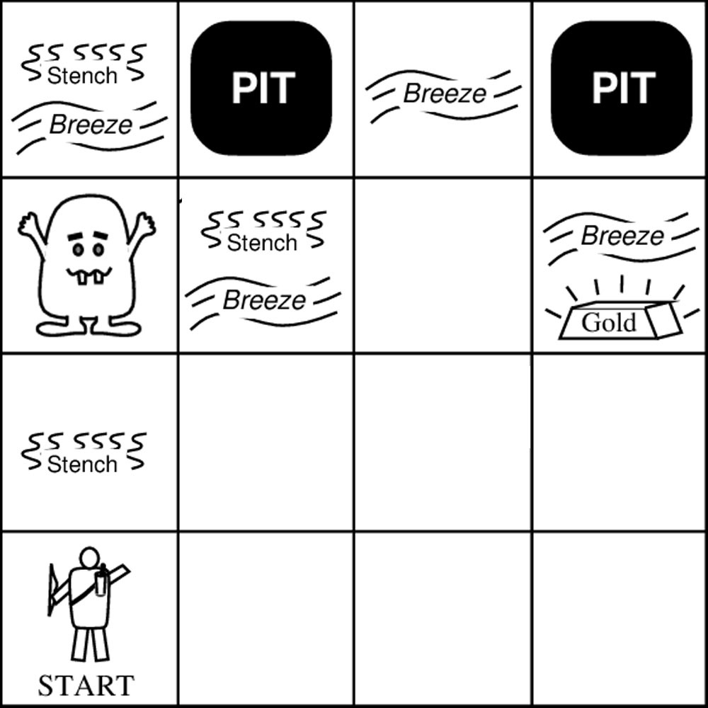

**Result :**

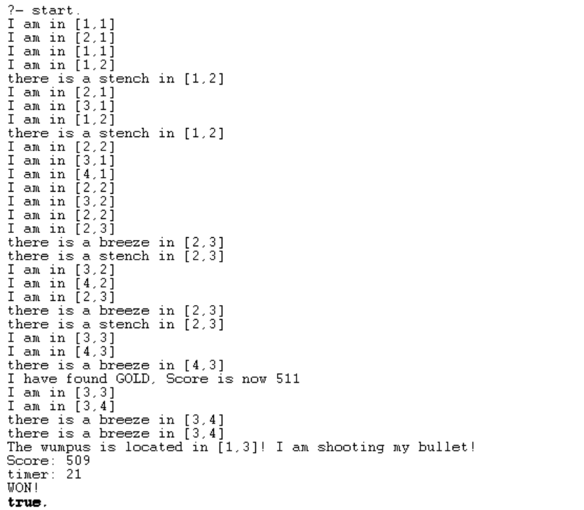

* **Here, the Wampus started at [1,1], then it goes to [2, 1], it found nothing then it came back to [1,1] then to [1,2], it founds a stench at [1, 2], then it continues its way to [2,2], while exploring it went to [3,1], [4,1], [2,2], [3,2], [2,2] and [2,3], it founds a breeze and a stench at [2,3], he continues to [3,2] then [4,2] then [2,3], he found again a breeze and a stench in [2,3], then an empty [3,3], then a breeze in [4,3] and he found the gold also there, he went back to where the wampus is, in [1,3], he shot it with bullet and the agent won.**

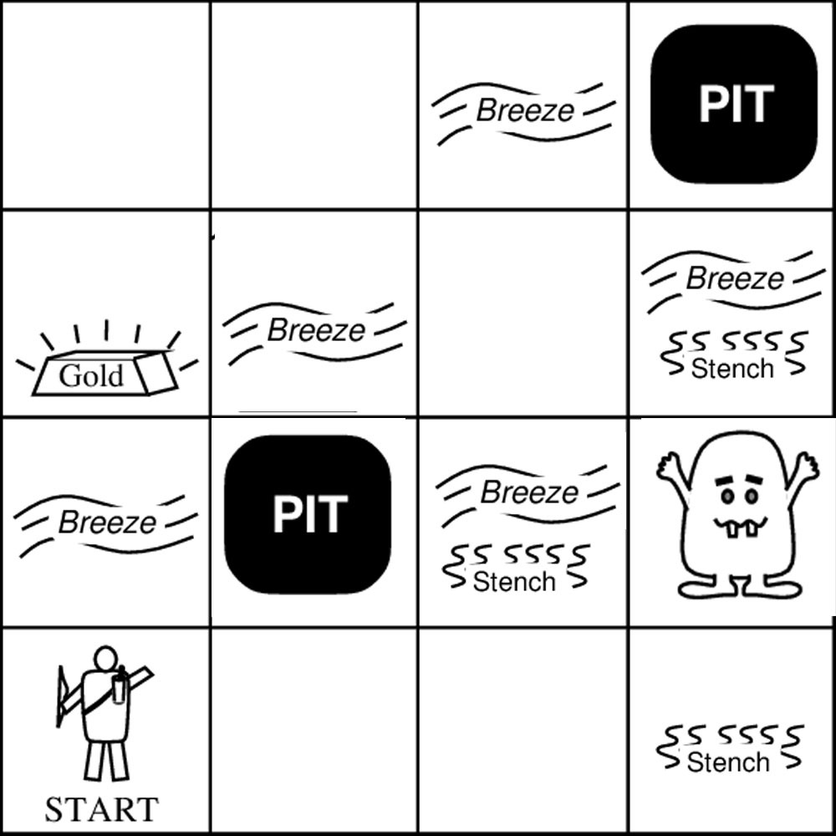**Layout 2 :**

Result :

* With the same process as before, the agent won again without any problems at this situation and the following situation as well:

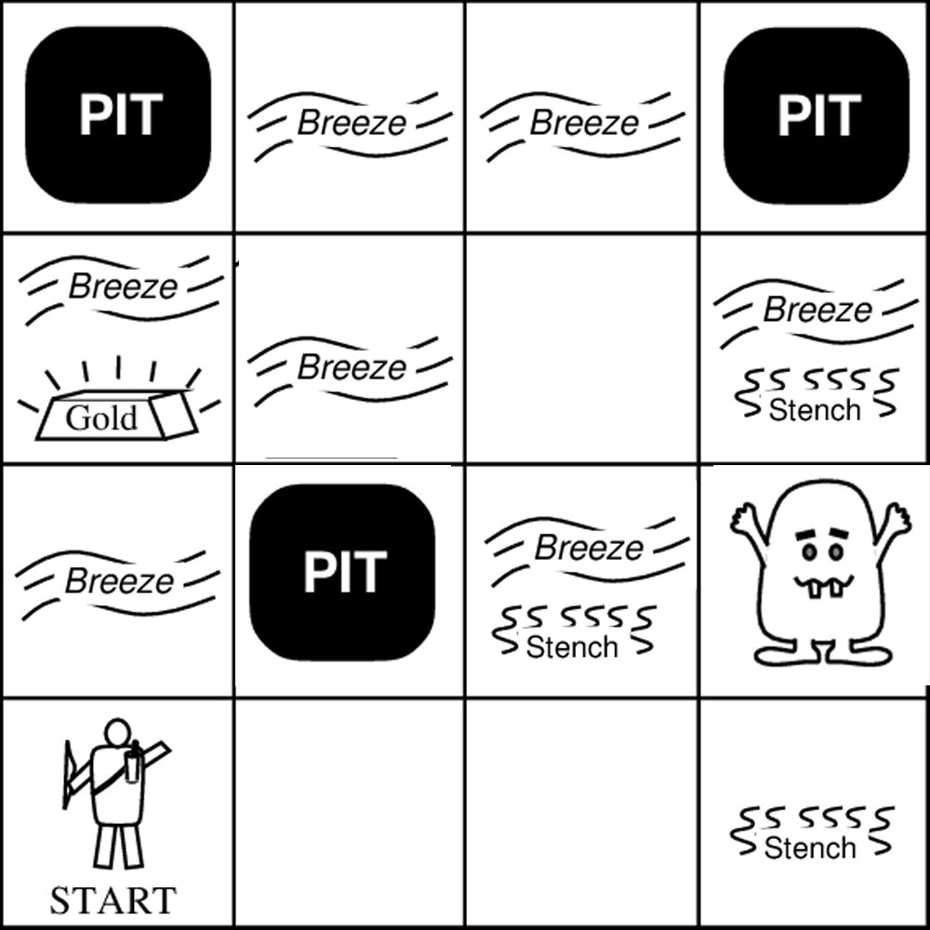

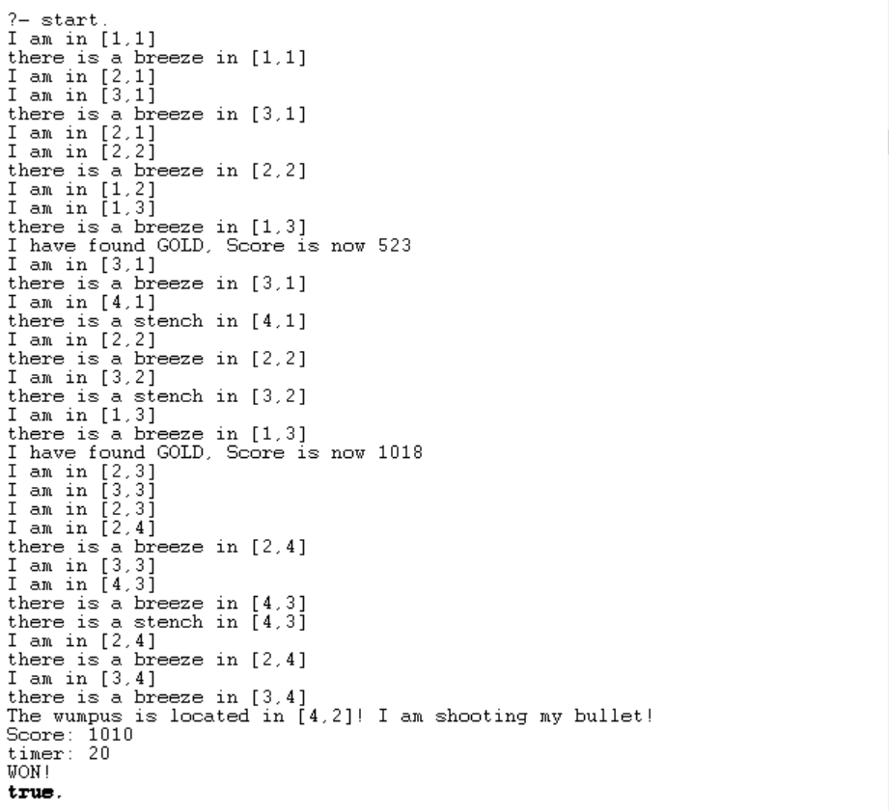

* At the next situation, the agent had failed in capturing the wampus even if he found the gold:

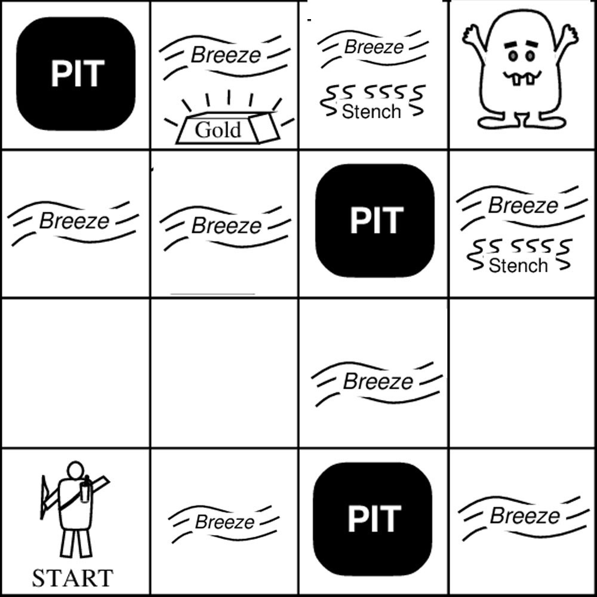

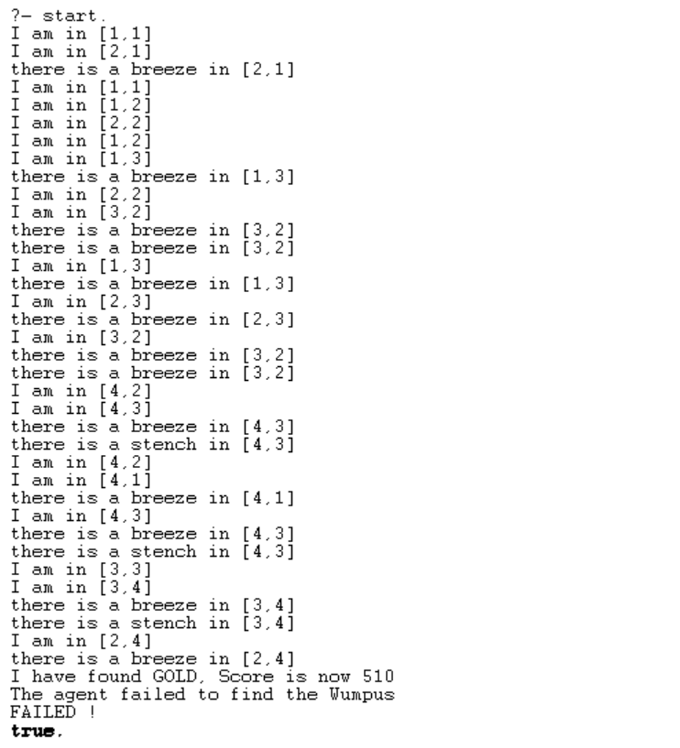

* 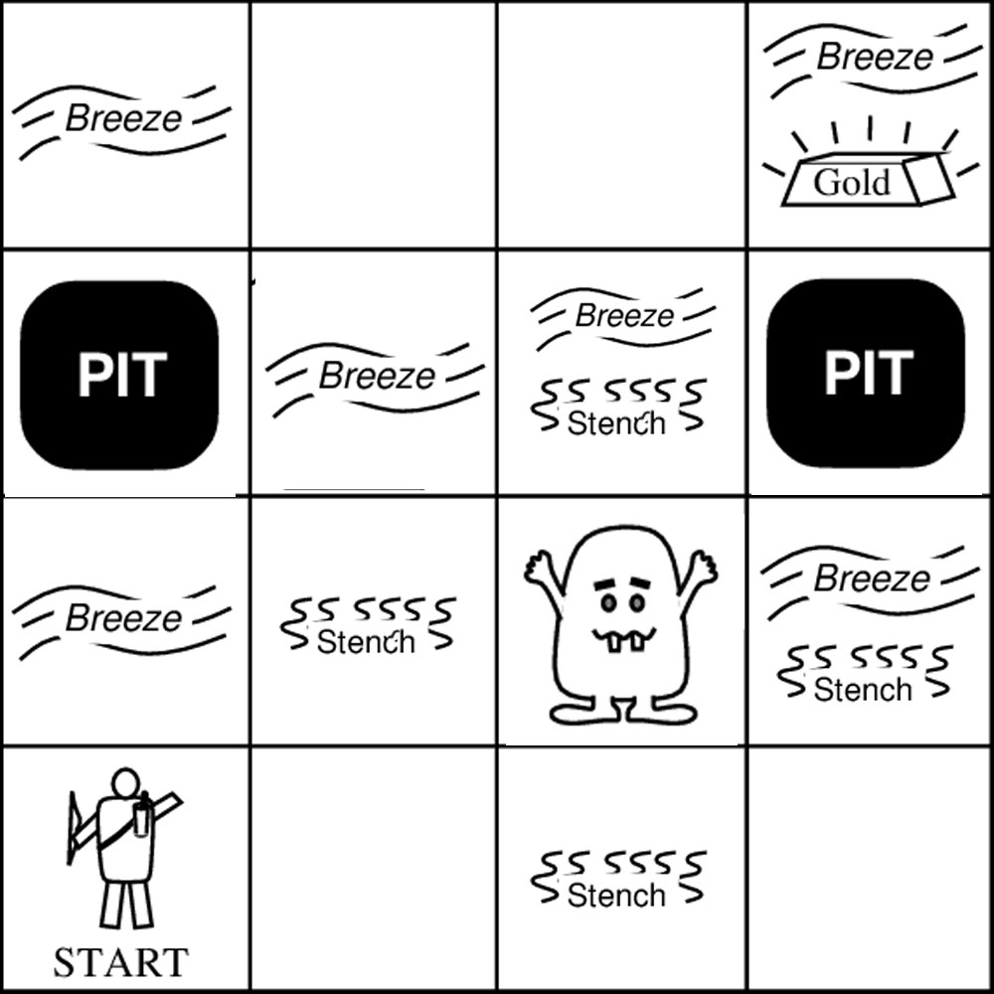And at this last situation, we faced the same problem as the first one, where the output told us that the wampus is on [3,0], but there is no [3,0] in the grid:

